Allstar Cheer Non-Travel Program 4-9 Years Old 2022-23 Registration Packet

Congratulations on choosing to become a part of one the largest and most successful Allstar gyms in the country! We are delighted to have you here.

Our non-travel cheer program is designed for our younger athletes ages 9 and under! (Born between 2013-2016)
Tiny and Mini non-travel teams will compete 4-5 times throughout the season. Your athlete will be competing in the prep or novice division to offer them a taste of what Allstar cheerleading is about. This will be a great introduction to the sport, whether there interests maybe in Allstars or school cheer

TRADITIONAL REGISTRATION (PRINTED FORMS FROM OUR WEBSITE): You are required to turn in the
Financial Commitment/Credit Card Info page, Tryout Form, Participant Information Form, Participant Agreement Form and your first payment of $200.00. You will sign up for an assessment date at this time also. NO INCOMPLETE PACKETS WILL BE ACCEPTED.
TUITION:
$200.00 upon registration plus 7 additional payments of $200.00 due by the 7th of each month starting in September 2022. All payments made payable to The Stingray Allstars.

TUITION:
All payments made to The Stingray Allstars. Tuition includes:
- All team practices
- A reserved spot in a one-hour weekly tumble class plus 1 additional drop in per week. (when available)
- Choreography, music, and competition fees
- Gym wide t-shirt

Mandatory items not included in tuition:
- Uniforms must be purchased the cost is $185.00
- USASF fee

- Briefs and sports bra to wear with your uniform
- White cheer shoes
- 2 practice wear outfits
(With the exception of our competition uniform, all these items can be ordered thru our pro shop, Full Out Sports, payment required when ordering).

Optional Items include: Stingray backpack, while not mandatory, this is the only bag that can be carried at a competition. Warm ups are available to purchase but not required for our non- travel teams. These items will also be available through Full Out Sports.

BILLING: Your monthly fees will be billed to your Stingray account on the 1st of each month (September-April). Fees are due on or before the 7th of each month. On the 8th of each month any outstanding balance will be charged to the credit card that you provided. The Stingray Allstars accepts cash, checks, money orders and debit/credit cards. You may also pay online cartesville,stingrayallstars.com. follow the prompts. If you have any questions about your account, feel free to contact the office,
770-607-0750 or cartersville@stingrayallstars.com.

Everyone MUST turn in this competed form.

PARTICIPANT INFORMATION
Cartersville Cheer Co. LLC
DBA The Stingray Allstars
199 Hickory Lane
Cartersville, Ga. 30120

Mother/Guardian
First: Last: ______________________________________

Father/Guardian
First: Last: ______________________________________

Phone Number :___________________________________

Mother/Guardian Cell: Father/Guardian Cell:
Emergency Contact Name: Phone Number:

Billing Address:

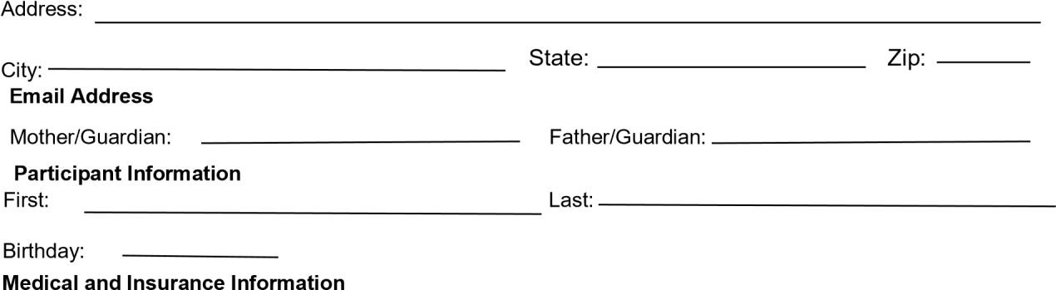
Medical Insurance Provider: _________________________________ Policy No./ Group No: ______________________________________
Provider Address /City/State/Zip: _____________________________________________________________________________________
Provider Number: ______________________________________
Is the Participant currently being treated for any type of medical condition? YES or NO (Circle One)
If YES, please explain: ______________________________________________________________________________________________
Is the Participant allergic to any known medications or suffer from any allergies? YES or NO (circle one)
If YES, please explain: ________________________________________________________________________________________________
Is the Participant currently taking ANY medications? YES or NO (circle one)
If Yes, please explain: _______________________________________________________________________________________________
Are there any other known medical issues or conditions that we should be made aware of? YES or NO (circle one)
If YES, please explain: _______________________________________________________________________________________

Carefully read this entire form. This form must be completed in full, signed, and returned before your child may participate in any Activities (as defines below).

PARTICIPANT AGREEMENT
As parent or legal guardian of ___________________________________________, a minor (“Minor”), and in consideration for Minor’s participation in the cheerleading, dance and other activities and services, including, without limitation, travel to and from such activities, competitions, conferences, meetings, and other events that may require travel (collectively, the “Activities”), conducted and provided by Cartersville Cheer Company LLC, a Georgia limited liability company, Stingray Gymnastic LLC, a Georgia limited liability company and their respective affiliated entities, owners, agents, officers, employees, representatives, and all other persons or entities acting in any capacity on their behalf (collectively, “SA”), I AGREE AS
FOLLOWS: I. Liability Release. ON BEHALF OF MYSELF AND MY HEIRS, ASSIGNS, EXECUTORS, AND ADMINISTRATORS, I
RELEASE AND FOREVER DISCHARGE SA FROM ALL CLAIMS, JUDGEMENTS, LOSSES, LIABILITIES, DAMAGES, COSTS, AND
EXPENSES (COLLECTIVELY, THE “CLAIMS”) OF ANY NATURE ARISING OUT OF OR IN ANYWAY RELATED TO THE MINOR’S
PARTICIPATION IN THE ACTIVITES WHETHER OCCURING ON THE PREMISES OF ANY SA LOCATION OR ANY OTHER LOCATION; I FURTHER AGREE TO DEFEND, INDEMNIFY, AND HOLD HARMLESS SA FROM AND AGAINST ANY AND ALL SUCH
CLAIMS, INCLUDING, WITHOUT LIMITATION, ATTORNEYS’ AND OTHER PROFESSIONALS’ FEES AND COSTS.
I understand that this release and discharge of Claims includes, without limitation, any Claims based on the negligence, action, or inaction of SA and covers personal and bodily injury (including death) and property damage, whether suffered by Minor before, during, or after participation in any Activities, and includes all Claims arising from the publication of use of any photograph, videotape, or narrative in any media. I acknowledge that SA makes no representations or warranties, either express or implied, regarding the condition or suitability of SA’s or any other locations or equipment for the Activities. The laws of the State of Georgia shall govern this release and indemnity agreement.
- Medical Release. I acknowledge and agree that Minor’s participation in the Activities subjects Minor to the possibility of physical illness or serious injury (including death). I further acknowledge and agree that Minor is assuming the risk of such physical illness or serious injury (including death) by participating in the Activities. In the event of such physical illness or injury, I authorize SA to obtain necessary medical treatment for Minor and I release, hold harmless, and forever discharge SA from any Claims arising from or related to any physical illness or serious injury (including death) and to the exercise of this authority. I further acknowledge and agree that I will be responsible for any and all medical and related costs and expenses incurred by and on behalf of Minor for any such physical illness or injury.
- Appearance Agreement. I understand that SA may from time to time produce promotional and other audio or visual materials and media relating to the Activities (the “Promotional Material”). I understand that, as a participant in or spectator of such Activities, Minor may be included in video recordings, audio recordings, photographs, and images taken during Activities for use in Promotional Material.

THEREFORE, I HEREBY ASSIGN, TRANSFER, AND GRANT TO SA, WITHOUT RESERVATION OR LIMITATION, THE ROYALTY-FREE,
EXCLUSIVE RIGHT TO USE SUCH VIDEO RECORDINGS, AUDIO RECORDINGS, PHOTGRAPHS, AND IMAGES OF MINOR, AS WELL AS
MINOR’S NAME, LIKENESS, PERSONAL AND DEMOGRPAHIC INFORMATION, VOICE AND APPEARANCE AS PART OF ANY
PROMOTIONAL MATERIAL. IN GRANTING THIS LICENSE, I HEREBY WAIVE ANY RIGHT TO INSPECT OR APPROVE ANY SUCH
PROMOTIONAL MATERIAL PRIOR TO PUBLICATION. I FURTHER AGREE THAT, UPON THE REQUEST OF SA, I SHALL IMMEDIATELY
REMOVE OR TAKE DOWN ANY PROMOTIONAL MATERIALS THAT MINOR OR I HAVE UPLOADED OR POSTED TO ANY WEBSITE OR SOCIAL MEDIA PLATFORM (INCLUDING, BUT NOT LIMITED TO, FACEBOOK, TWITTER, INSTAGRAM AND YOUTUBE), OR IN ANY OTHER PUBLIC FORUM.
- Confidentiality. I acknowledge and agree that SA develops and creates unique and valuable proprietary dance routines, cheerleading routines, training techniques, and other intellectual property that are unique and valuable to SA and that may be used to prepare for and participate in competitive events (collectively, the “Intellectual Property”); I further acknowledge and agree that maintaining the confidential and proprietary nature of the Intellectual Property is of the utmost importance to SA and its competitive success. I understand that I may video-record, audio-record, photograph, or take other images of the Intellectual Property solely for my, Minor’s, or Minor’s immediate family’s personal,
non-commercial use; PROVIDED ALWAYS, HOWEVER, THAT MINOR AND I SHALL NOT POST OR UPLOAD ANY SUCH RECORDINGS OR IMAGES TO ANY WEBSITE OR SOCIAL MEDIA PLATFORM (INCLUDING, BUT NOT LIMITED TO, FACEBOOK, TWITTER, INSTAGRAM, AND YOUTUBE), OR IN ANY PUBLIC FORUM WITHOUT THE PRIOR WRITTEN CONSENT OF SA.
- Breach. I ACKNOWLEDGE AND AGREE THAT ANY BREACH OR THREATENED BREACH OF SECTION IV OF THIS AGREEMENT
WILL CAUSE SA IRREPARABLE INJURY FOR WHICH NO ADEQUATE REMEDY AT LAW IS AVAILABLE AND I CONSENT TO THE ISSUANCE OF AN INJUNCTION PROHIBITING ANY CONDUCT VIOLATING THE TERMS OF SECTION IV. I ACKNOWLEDGE THAT ANY
VIOLATION OF THIS AGREEMENT BY MINOR OR BY ME MAY RESULT IN MINOR BEING SUPSENDED FROM OR PERMANENTLY
EXPELLED FROM PARTICIPATION IN SOME OR ALL ACTIVITIES AND MY SUSPENSION FROM ATTENDING AND SPECTATING SOME
OR ALL ACTIVITIES. I ACKNOWLEDGE THAT IN ANY CASE WHERE MINOR IS SUSPENDED OR PERMANENTLY EXPELLED FROM PARTICIPATION IN SOME OR ALL ACTIVITES, I WILL NOT BE ENTITLED TO ANY REFUND OF ANY AMOUNTS PAID FOR PARTICIPATION IN ANY CURRENT OR FUTURE ACTIVITES.
I have had sufficient time and opportunity to read this agreement. I have read this document in its entirety and understand it. Therefore, by affixing my signature below, I agree to be bound by the terms of this agreement.
PARENT/GUARDIAN: ___________________________ Minor: __________________________________________ Date: ________________________
Name (Print)_______________________________________________ Name (Print)_____________________________________ Date:__________________

Allstar Prep Assessment Form Everyone Must turn in this completed form.

Cheerleader’s Name: ________________________________________ _{DOB/Age:}

School: ____________________________________

Athlete’s Experience: __________________________________________________________________
Last gym cheered with (for USASF registration): _____________________________________________
STAFF USE ONLY BELOW THIS
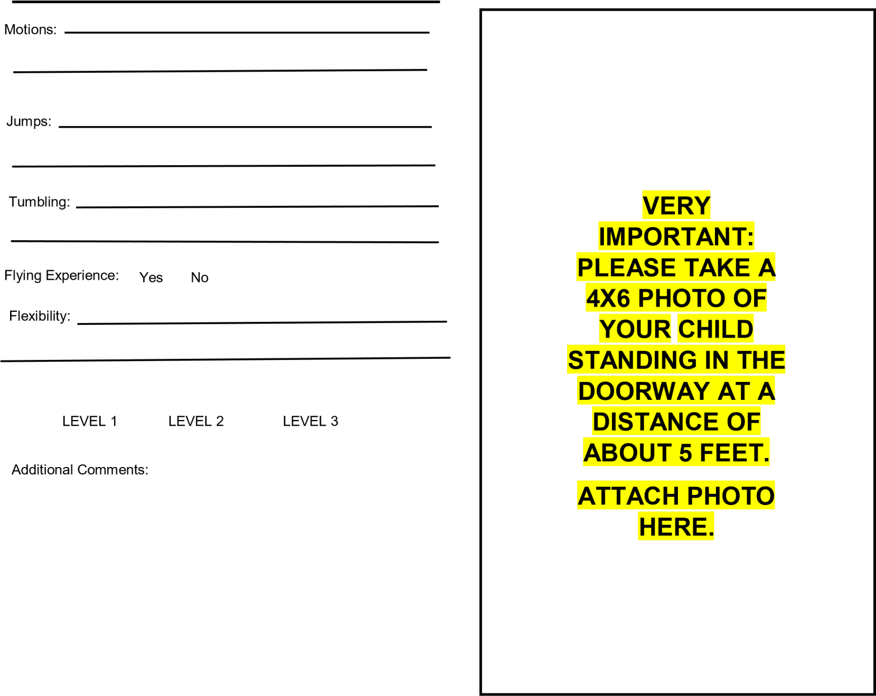

Financial Commitment/ Credit Card Information
Turn this form in with your completed packet.
Financial Commitment
(Billing Authorization)

I have read the Allstar Prep Registration Packet and fully understand my financial commitment to The
Stingray Allstars outlined in this document. I understand that my commitment is for the 2022-2023 Allstar Prep competitive season. I understand that I am giving my credit card/debit card information and that information will be used if I do not meet payment deadlines to Cartersville Cheer Co. LLC/ The Stingray Allstars

I understand that I will forfeit any monies paid if I choose to leave a team or am asked to leave the program. I understand that I am entering into this program of my own free will.

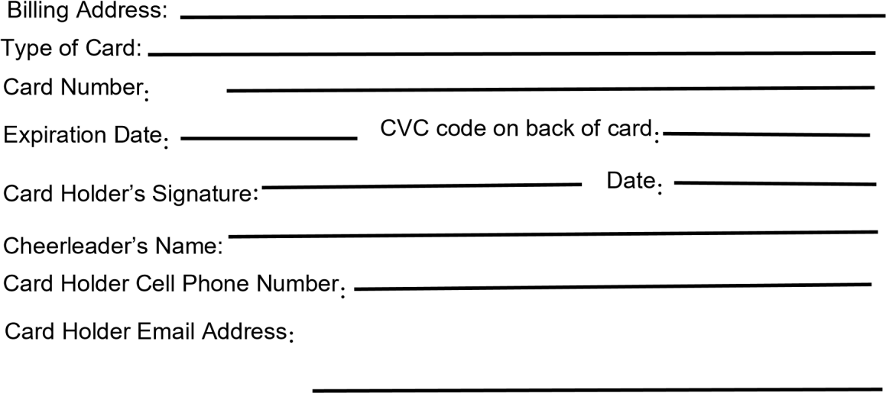
Parent Signature:

Name as it appears on the card
:

EVERYONE is required to submit credit card/debit card information and to be on autopay.
It is your responsibility to inform the office of any changes to this card.
Monthly fees are billed to your Stingray account on the 1st of every month. Payment is expected on or before the 7th. This credit/debit card will be charged for any outstanding balance on the 8th.

By signing this page, you understand that you are committing to paying $200.00 for 8 months.

